**Cloud Storage**

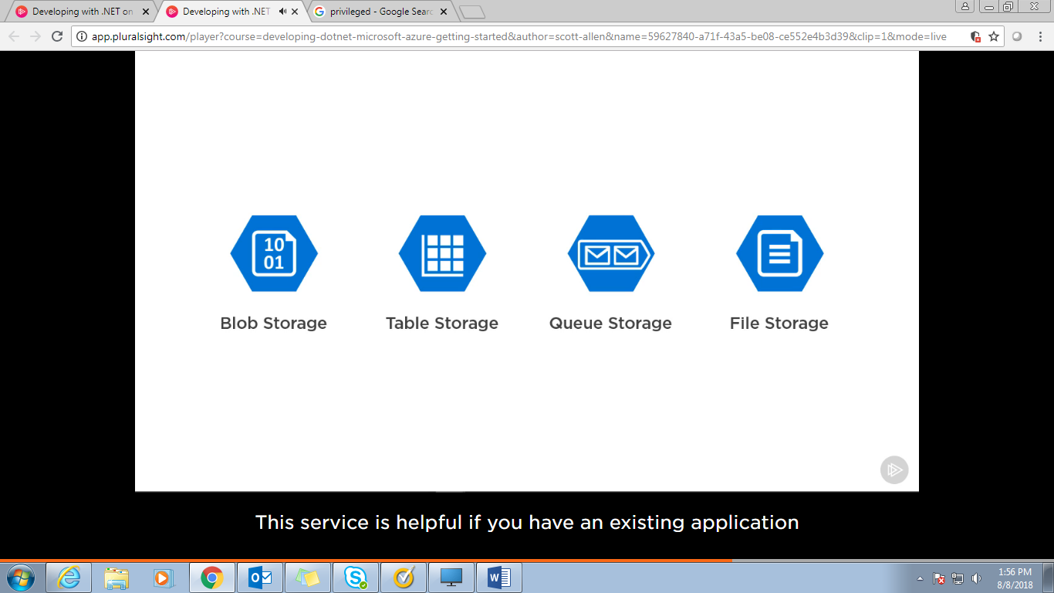

Blob Storage🡪binary Large Object ,movie song script C# code

Table Storage🡪collection of key value peers, type of database

Queue Storage🡪allow to store and retrieve messages, allows you to put a buffer between your application and backend services that it uses, allows asynchronous operation which is more efficient

File Storage🡪allow you to set up SMB file shares in the cloud. This service is helpful if you have an existing application that you want to put on azure and application already uses file shares.

Disk Storage🡪 designed to store OS and data disc attached to your virtual machines.

Blob Storage:

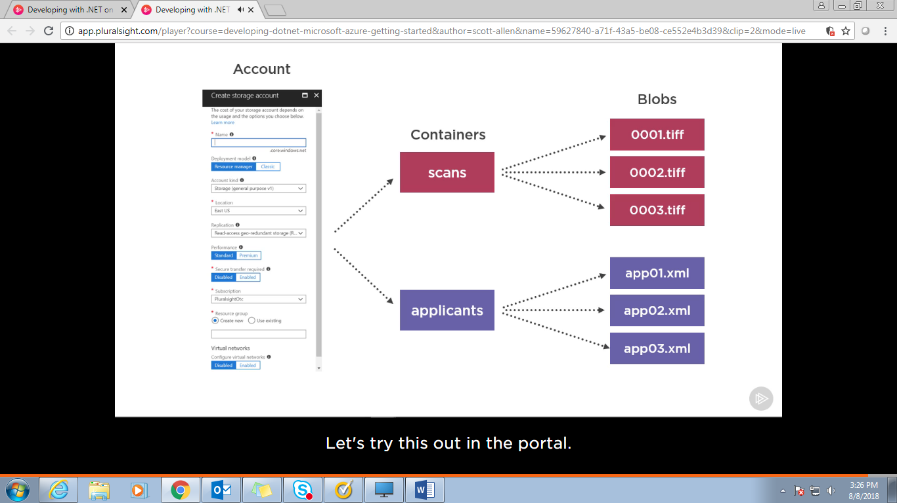

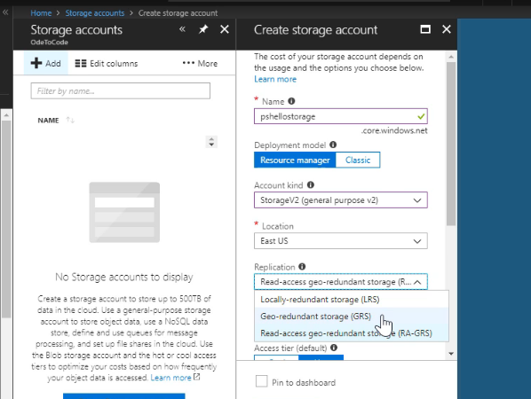

Write data ay three databases then write operation completes.

See pricing calculator at Azure:

https://azure.microsoft.com/en-in/pricing/calculator/?cdn=disable

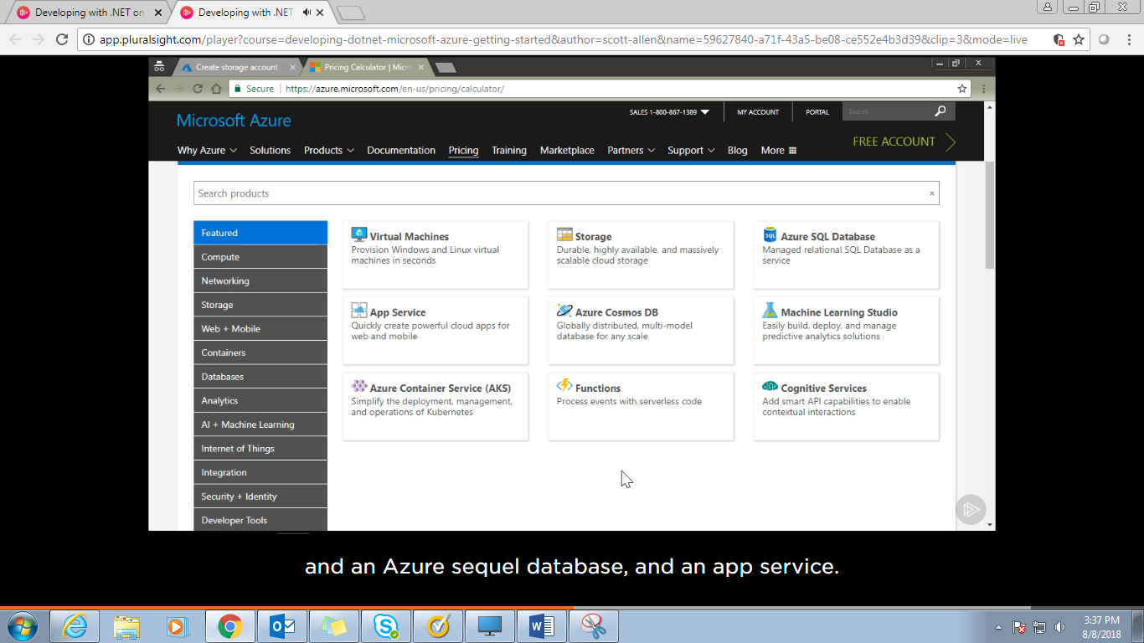 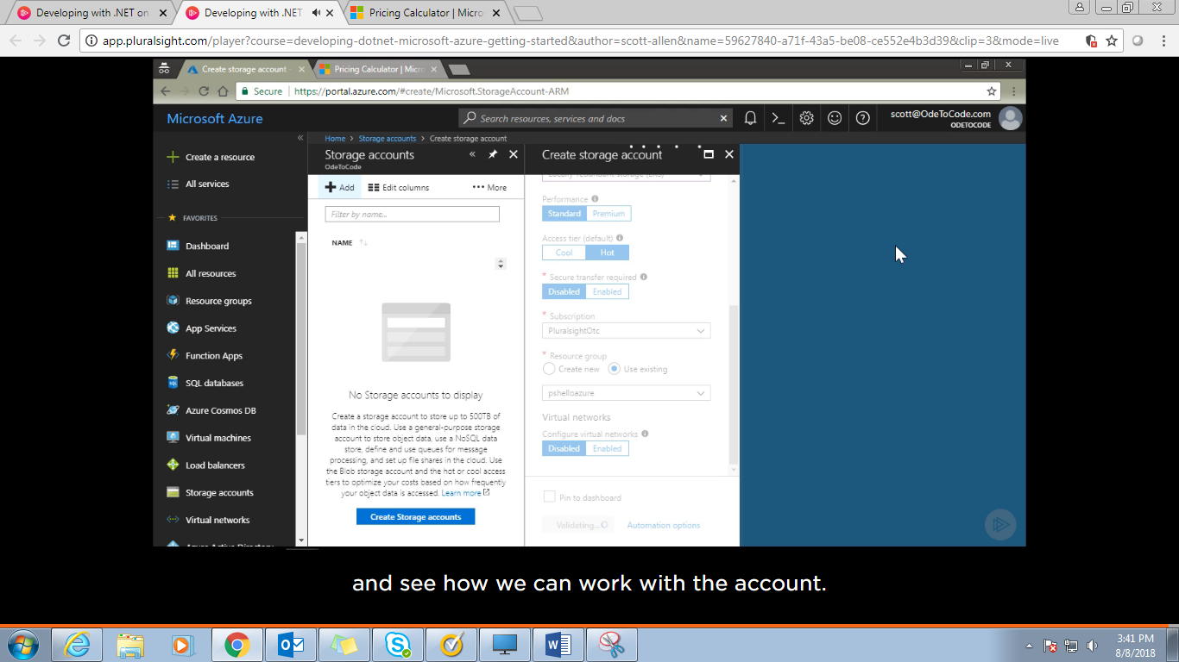 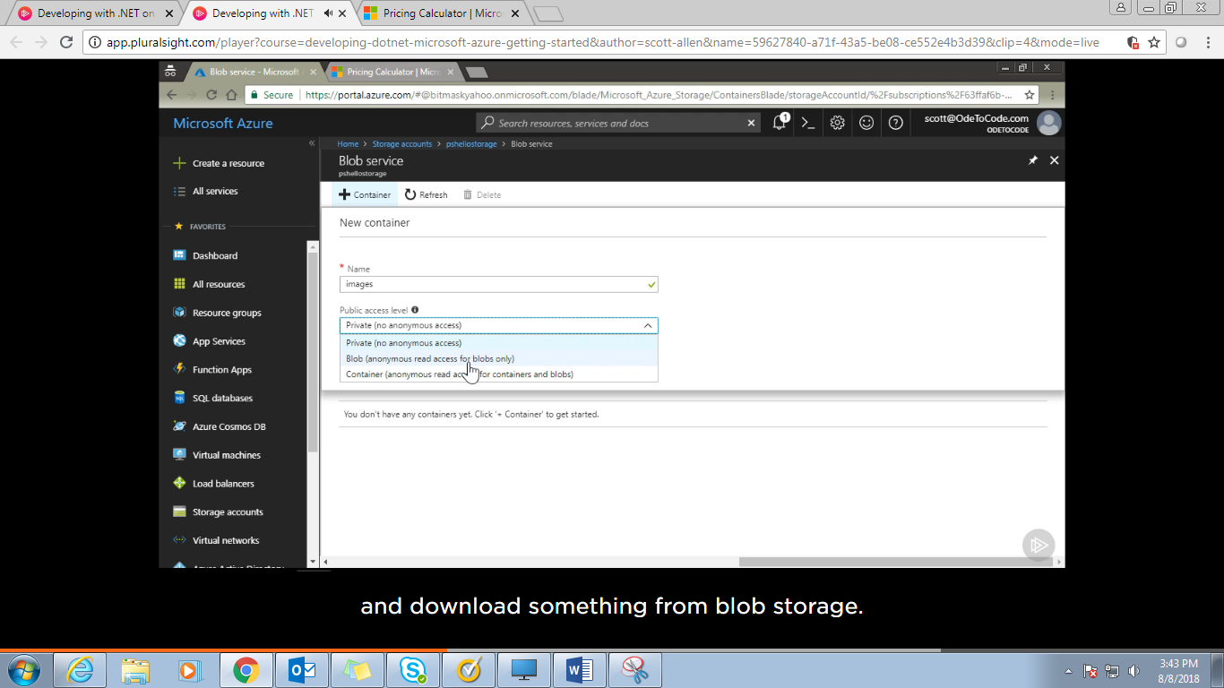

Azure Storage explorer tool to handle blob storage. To upload and retrive data.

We can also upload by Visual studio coding:

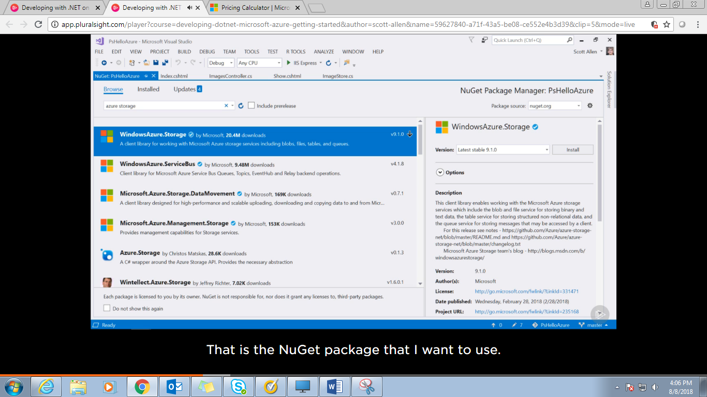

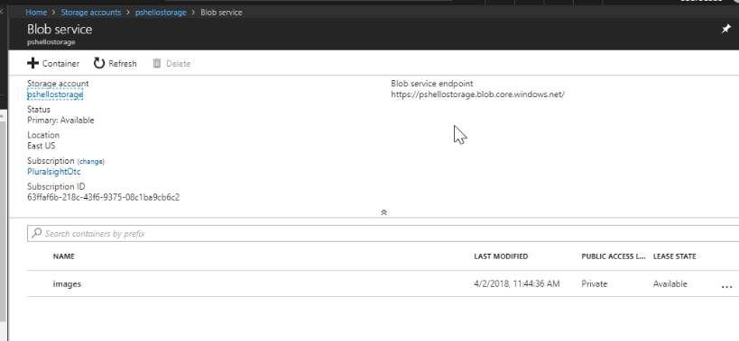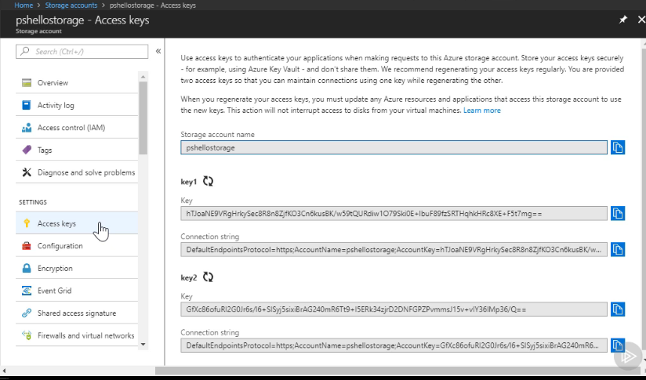

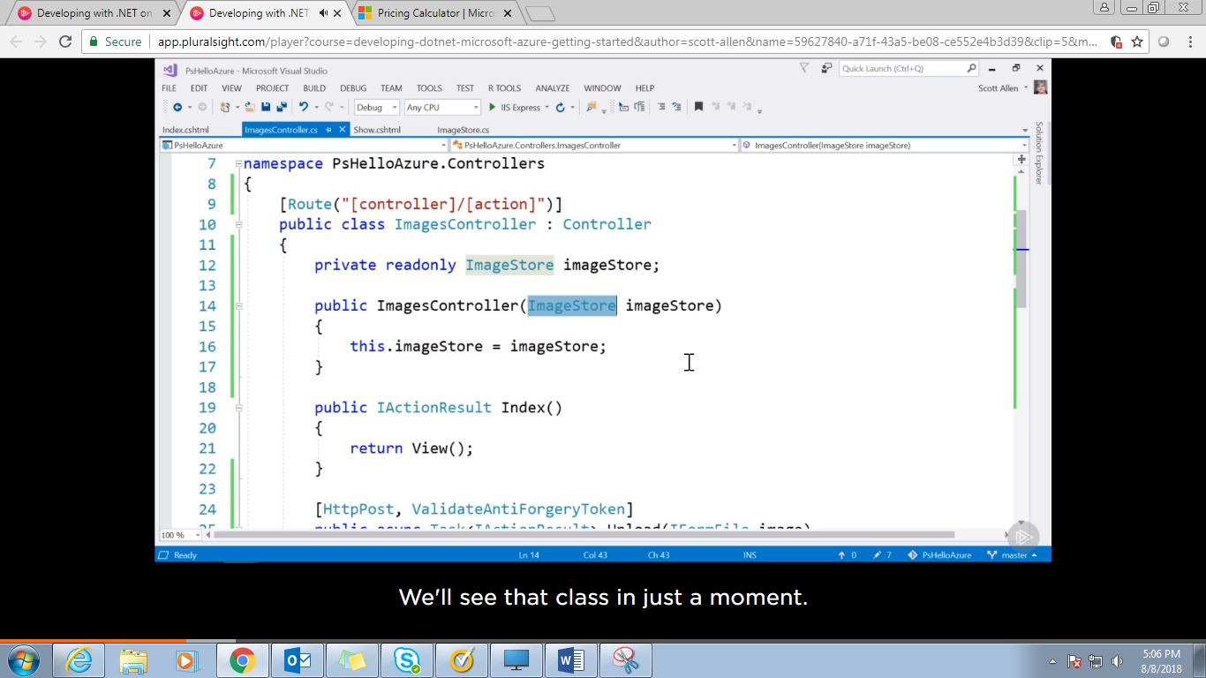 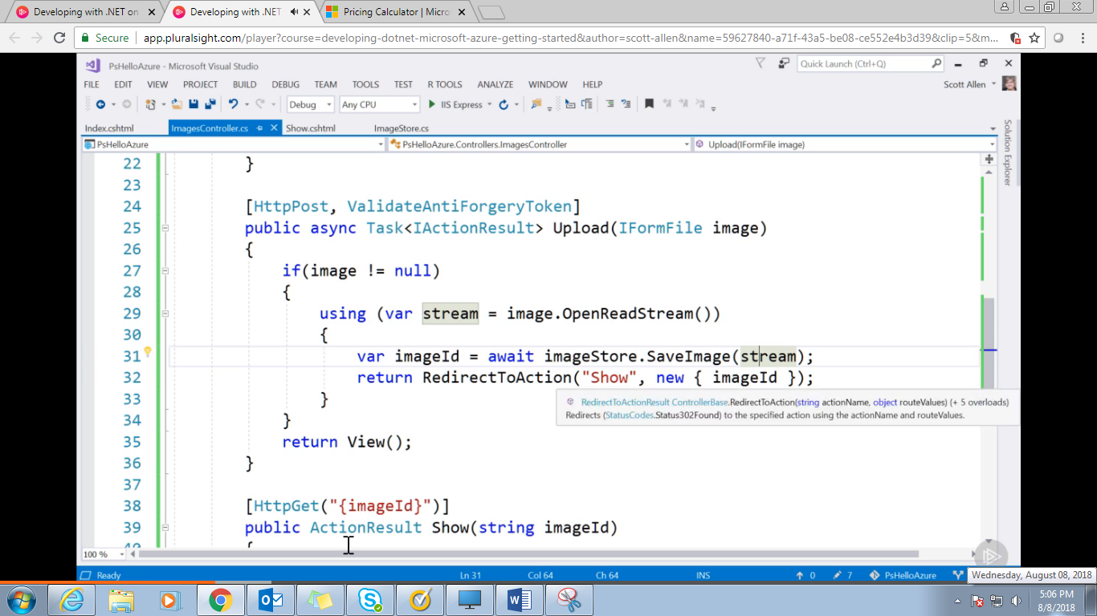 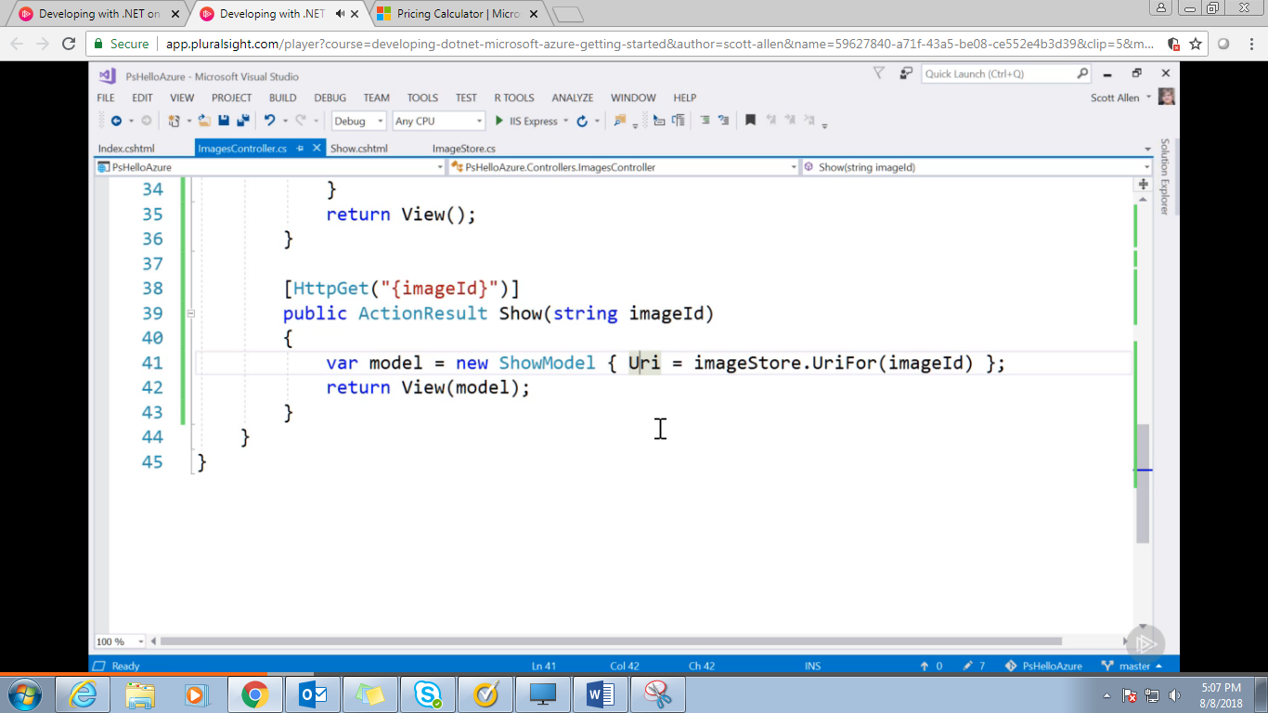 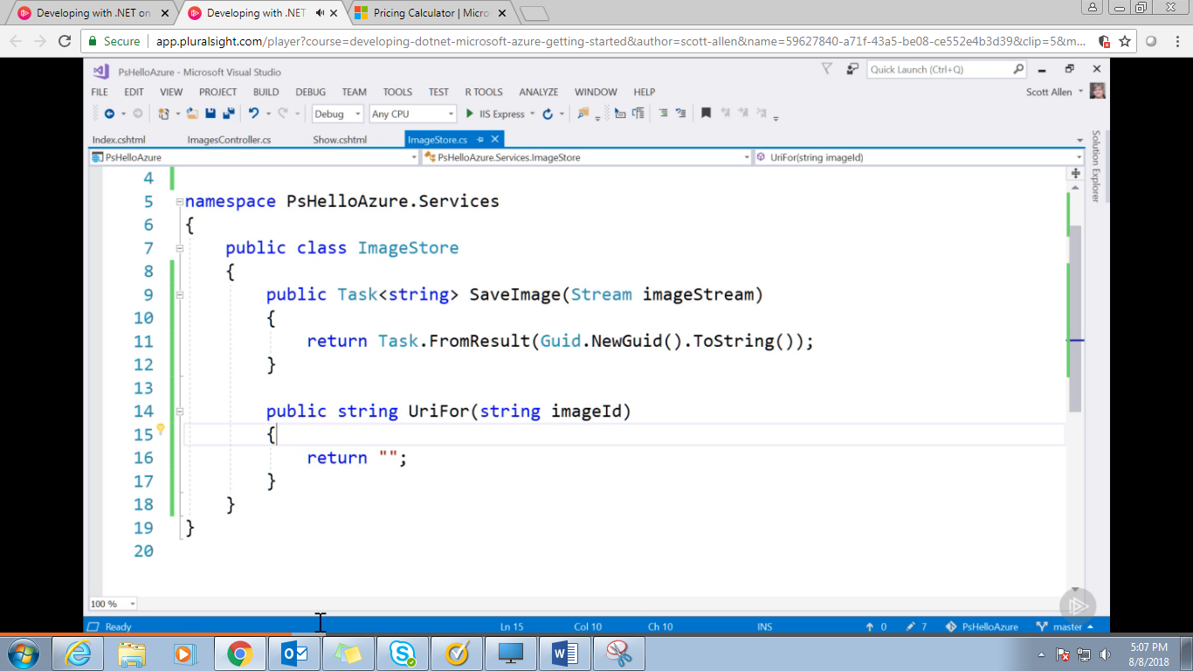 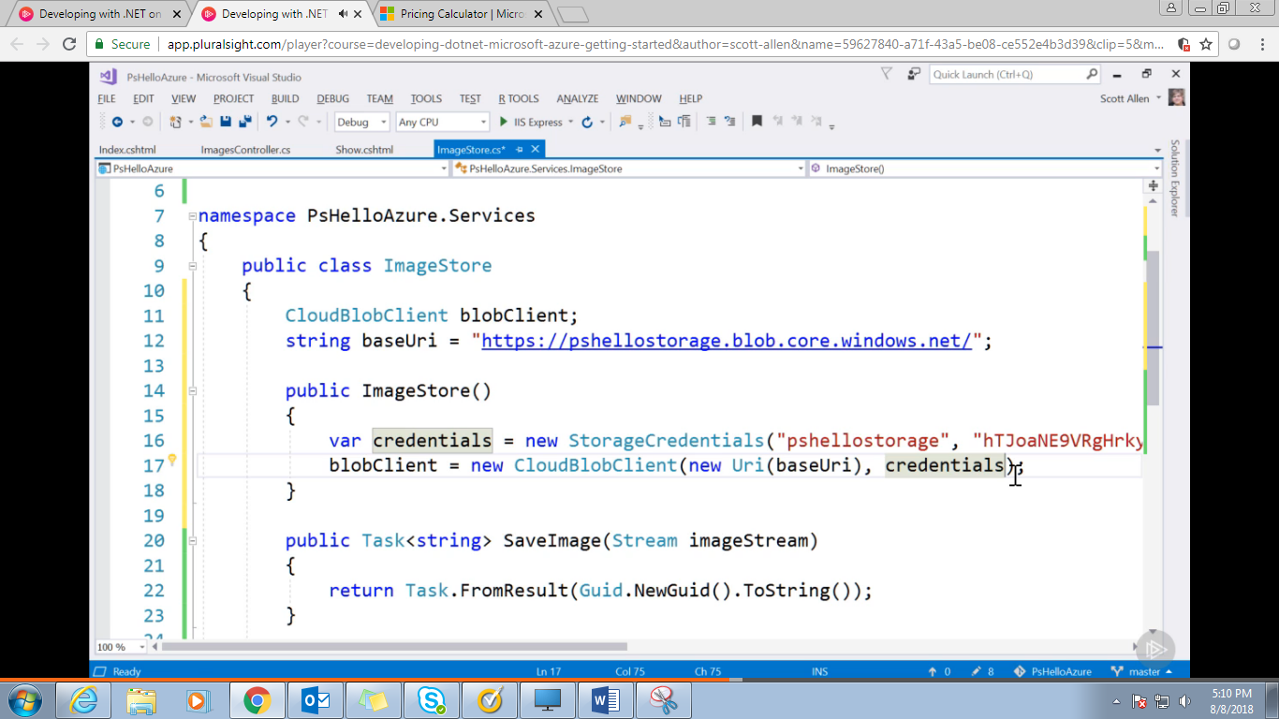 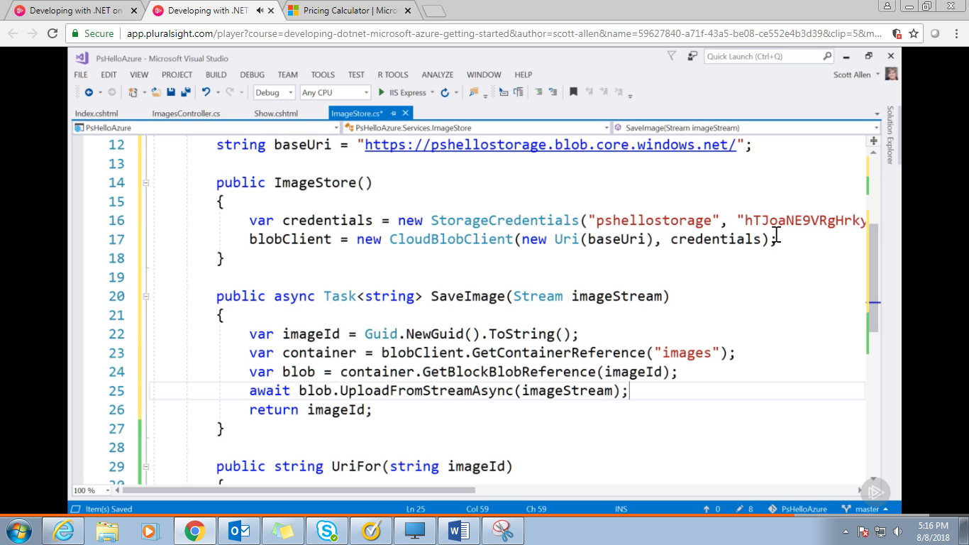

Shared Access Signature:

Token that gives a limited permission to a blob or a container

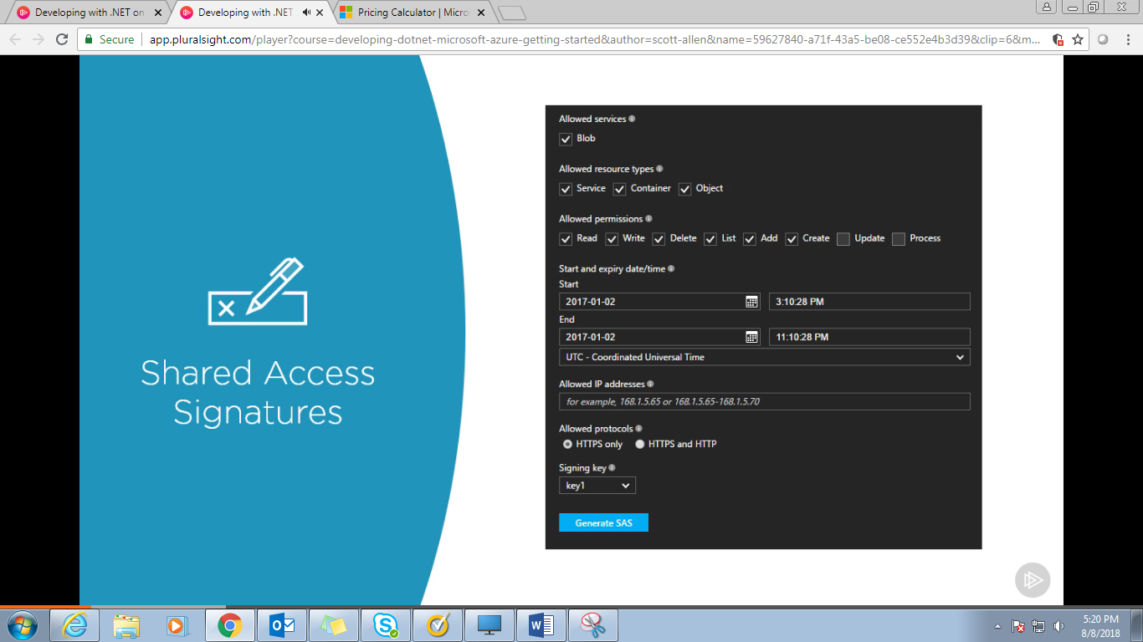

We can do this by azure portal or we can do this by visual studio.

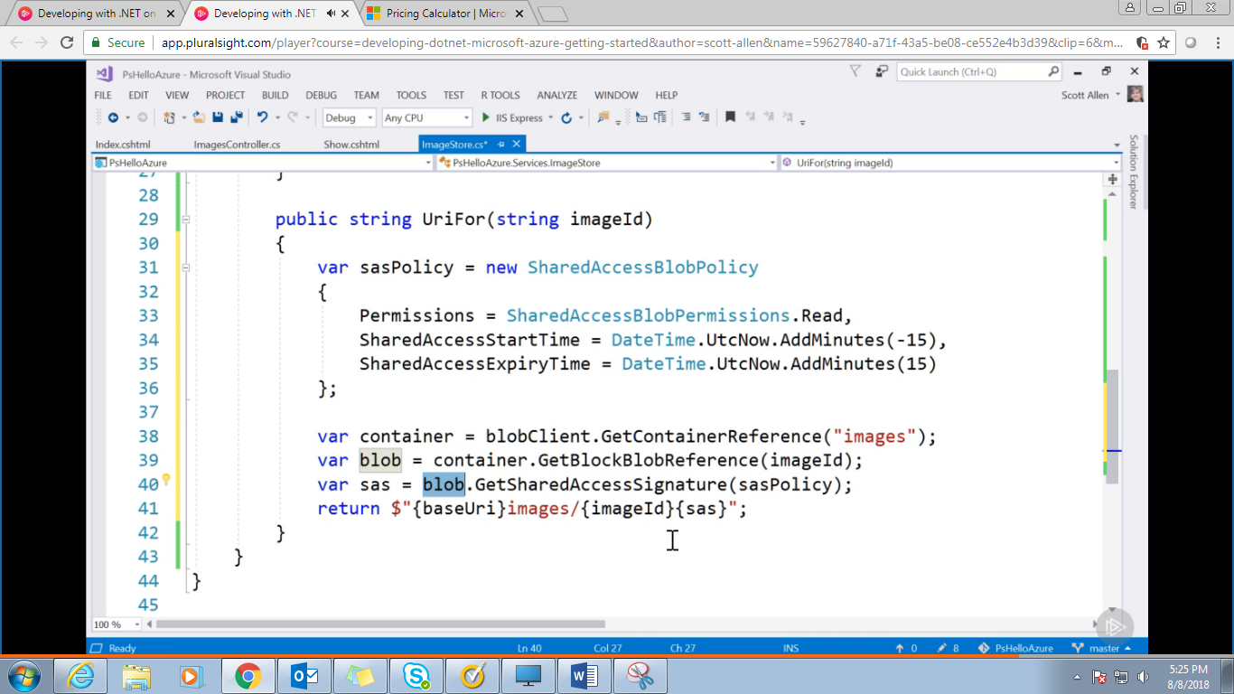 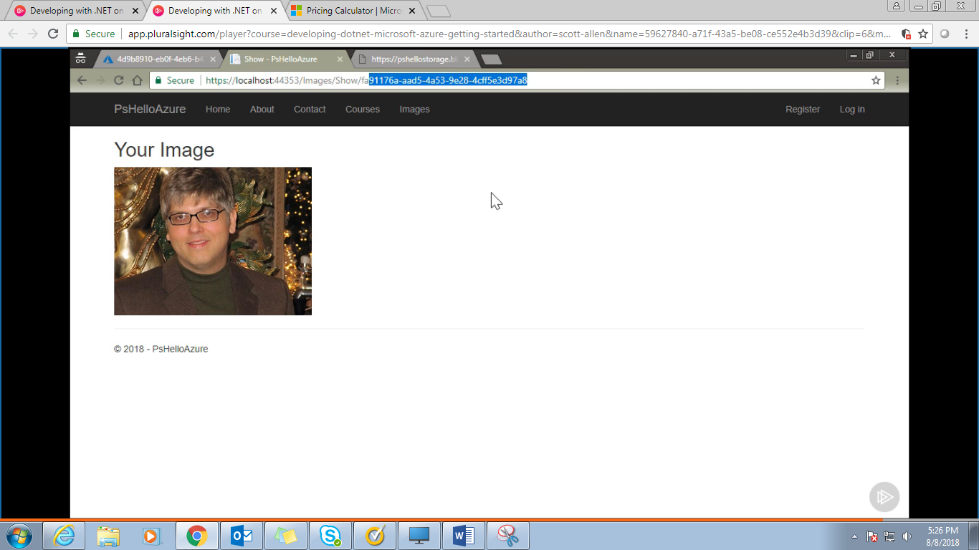 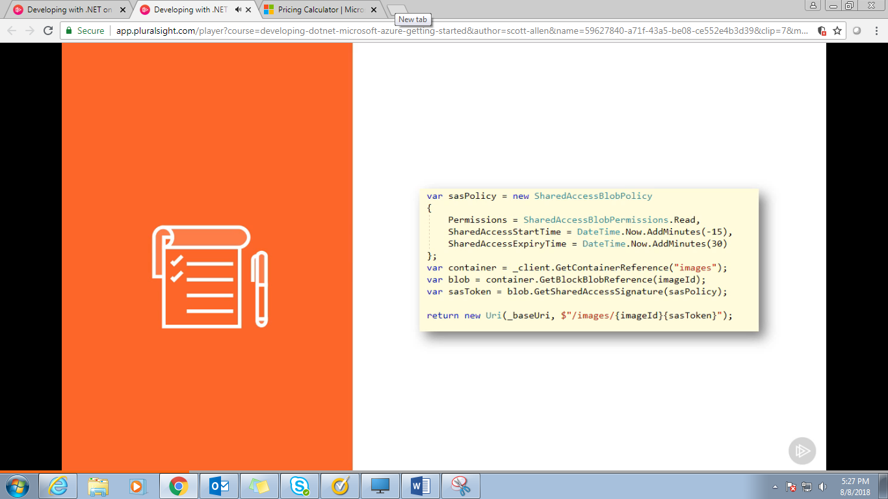

**FUNCTIONS:**